Pokhara University

Level: Bachelor | Semester – Fall | Year : 2011
Programme: BE |  | Full Marks: 100
Course: Web Technology |  | Pass Marks: 45
 |  | Time : 3hrs.

Candidates are required to give their answers in their own words as far as practicable.
The figures in the margin indicate full marks.

Attempt all the questions.

 | - Discuss the need of web browser and web server in accessing the Internet.  - List the different MIME headers and explain them.  - Discuss the need of HTML? Illustrate with a very basic example the structure of a simple HTML document. | 5  5  5
 | - Write the form code for the following image.  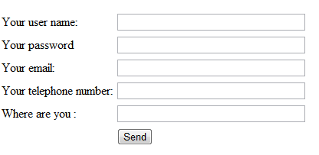  - What are the different levels of style sheets with their hierarchy of implementation to a file? Explain the DIV and SPAN tags with a valid and detailed example. | 5  10
 | - Why is JavaScript called client side scripting language? Explain the advantages of using client side scripting language. Support your answer with an example scenario.  - What is DOM? Write a code synopsis to represent dragging and dropping of elements in JavaScript. | 8  7
 | - Using JavaScript and forms prepare a HTML document to find (and display in a textbox) the factorial of an entered number. Also display the message in alert box if the factorial is divisible by both 2 and 5 or not.  - Why PHP is called server side scripting language? Briefly explain any five general syntactic characteristics of PHP. | 8  7
 | - How can we connect to a database using PHP? Write working code to connect to the database and save the contents of the form in question no 2a) above.  - List and briefly explain the arithmetic and logical operators used in PHP. | 10  5
 | - What do you understand by file handling? Write a program using PHP and HTML forms containing 3 text fields and 1 number field, and write the content of the fields to a text file on the click of a submit button.  - What is SOAP? Discuss a scenario where we can use a SOAP envelope. | 8  7
 | Write short notes on any two:  - RSS and usage of RSS Feeds  - Significance of HTTP Request and Response headers  - Trends of Electronic Payment System in Nepal | 2×5

